Hometown

HEROES
BANNER PROGRAM - APPLICATION

Grand Rapids

A P P L I C A N T S I N F O R M A T I O N
A

Your Full Name : (or Organization)
Relationship to service member : (if any)
Your Address :

Postcode :

E-Mail :
City/County :

Phone Number :
H O M E T O W N H E R O E S I N F O R M A T I O N
B

Full Name
(As displayed) Military Service
:

: Air Force

Army

Coast Guard

Marine Corps

Navy Space Force

Active Duty Retired Veteran

Other Information: Banner gifted by etc.

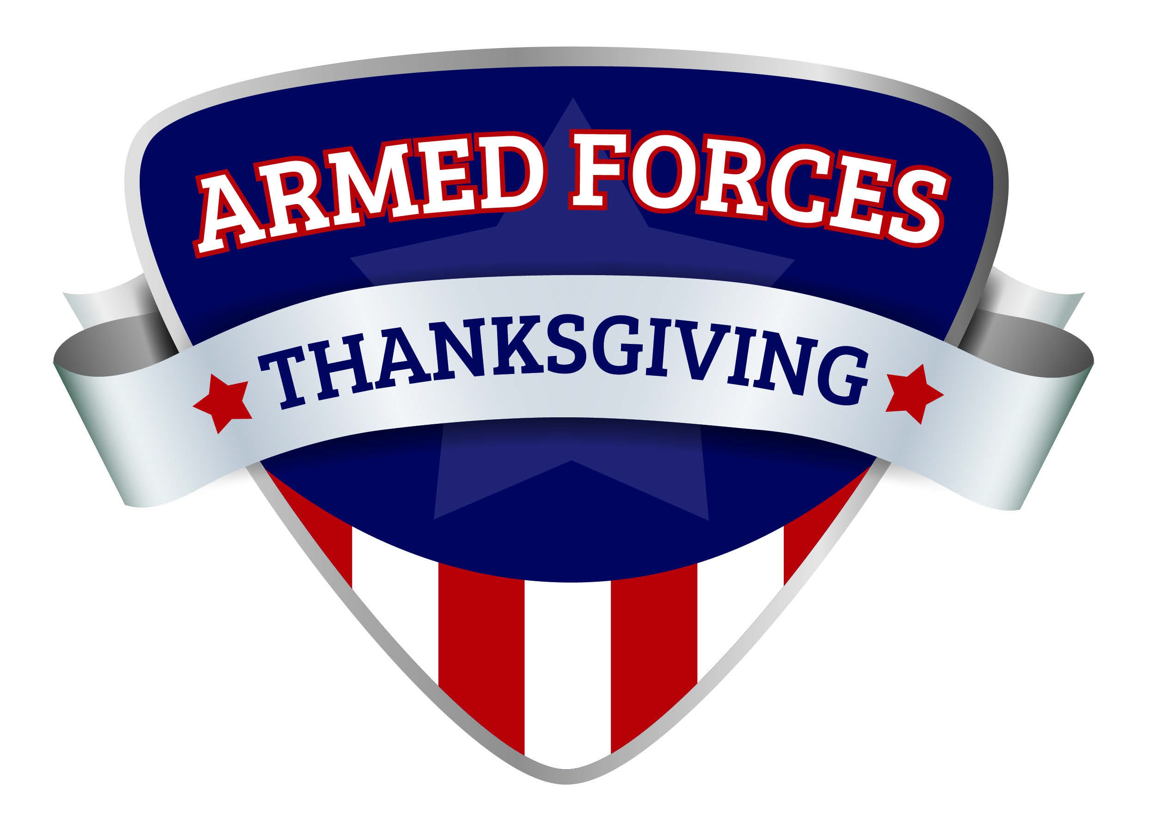
Payment Details: Each Banner is $300.00
Make Checks Payable to: Armed Forces Thanksgiving
(If you prefer to pay by credit card – you can complete payment via our website: www.armedforcesthx.org)

Completed forms and digital photos can be sent electronically to Suzannewickman@gmail.com or mailed to:

Mail Form/Photo and Checks to: Armed Forces Thanksgiving
C/O Advantage Benefits Group 1 Ionia St SW Ste 300
Grand Rapids, MI 49503
OFFICE USE ONLY:
PAID (CK/CC)
Date Received: __________

Yes
No
Applicant’s Name

Applicant’s Signature
FOR ANY ADDITIONAL INFORMATION EMAIL: SUZANNEWICKMAN@GMAIL.COM

